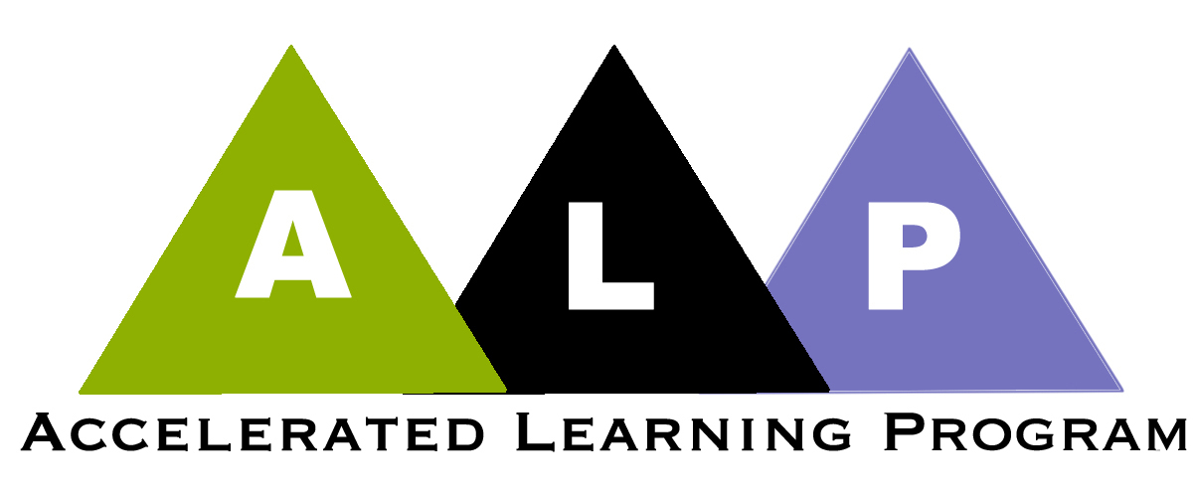

Key Pedagogic Features of ALP Courses

Listed below are what we think of as the key pedagogic features of ALP classrooms. This list is very much a work in progress. On some of these points, we have reached considerable consensus; others are still the focus of much controversy. Nevertheless, there is general agreement that these topics raise questions that teachers of ALP should be thinking about.

- Backward design curriculum development.

We think it’s important that developmental writing courses not be structured by taking a complicated process like writing or reading, breaking it into discrete isolated skills, and teaching those skills one at a time.

Instead, we take the “target” course, which the developmental course aims to prepare students for, and ask what do students in that course do. For ALP developmental courses, the target course is first-year composition, and what students do in that course is read challenging texts and write mature essays in response to them. We then design the curriculum for the developmental ALP courses “backwards” from that course. We do not break the tasks down into decontextualized skills like grammar exercises, paragraph writing, or reading short passages and identifying main ideas. Rather, in developmental ALP we ask students to read challenging texts and write mature essays in response to them. The major difference between this and what they do in first-year composition is that they do it more slowly, with more support, more scaffolding.

- Active learning in a writing classroom.

There is widespread recognition, with which we agree, that effective teaching usually involves a combination of lecture and more active forms of learning. Most of us, and we suspect most teachers of developmental writing have relied to heavily on lecture or lecture/discussion (which usually involves only a few students and the teacher doing the bulk of the discussing).

- Integrating reading with writing.

While integrating reading and writing is explicitly built in to the lower-level developmental courses at many schools, it seems to make great sense to continue integrating support for students as readers in the ALP developmental course and in the ALP first-year composition course. This doesn’t have to mean a major revision of the syllabi for these courses. Rather, it can simply mean that the instructors do not assume that all their students are proficient and engaged readers and that faculty are prepared to provide assistance with reading as it seems appropriate.

- Thinking skills in the writing classroom.

While writing is the key focus of ALP developmental and first-year and composition classes, we believe that the most important component of strong writing is strong thinking. We build into ALP courses discussion, activities, and writing requirements that encourage students to think more deeply as they read and write.

- Dealing with non-cognitive issues.

Recognizing that the most common factor for students who do not succeed in their developmental writing courses is not difficulty with writing, but difficulty in the rest of the students’ lives. Students frequently drop out of school because they become discouraged, stressed, or filled with insecurities. Other students give up because problems in their lives become overwhelming: they experience extreme financial difficulties, they are evicted, they lose their jobs, they or their children get sick, they find themselves in an abusive home situation, or some combination of factors like these.

While very few English teachers have any professional preparation in responding to these affective and life issues, we have discovered that we can, nevertheless, effectively make our classrooms places where students can discuss these problems, where they can receive advice (often from other students), and where instructors can, when the situation requires it, find outside help for students. In addition, we can structure our classes in ways that will improve our students chances of successfully responding to the problems their lives present.

- improving students ability to edit their own writing

In number 1, above, we expressed our view that the ALP developmental course should not feel like a grammar class to the students. We do not recommend that students arriving in these courses face weeks of exercises in identifying parts of speech and choosing the correct forms of verbs.

This does not, however, mean that we do not recognize an obligation to help students become more effective at editing their writing to reduce the frequency and severity of sentence level error. At CCBC, we are far from having solved the problem. But we have begun to develop some ideas that inform the way we attempt to help our students address sentence-level error.

First, we have generally agreed that the goal of any form of “grammar” instruction is to help our students become, not grammarians, but more effective editors of their writing. In most cases, this means a de-emphasis on learning grammatical terms and concepts and increased emphasis on editing their own writing. Most of us agree that whatever grammar we teach will only be effective if it is applied to the students’ own writing and that practice editing what they have written is much more useful than spending time doing grammar drills.

- coordinating the comp and the developmental classes

One of the big advantages of the ALP model is that the same instructor teaches both the credit composition course and the non-credit developmental course. This means that much of the time in the ALP developmental class is devoted to scaffolding for later assignments in the comp class. In some cases this means discussion of issues that will later be written about. In other cases it means actually writing short papers that are preparation for longer assignments upcoming in the comp class. Sometimes the coordination is focused more on an assigned reading—the ALP developmental class might do some preliminary work preparing the students for the style and complexity of a text to be read in the comp class.

The basic idea is to use the ALP class either as a place to help students prepare for upcoming work in the comp class or a place to review and clear up misunderstandings that arise in the comp class.

- writing projects not essay assignments

Instead of thinking of writing as a series of essay assignments, we like to think of it as a smaller number of projects, perhaps four for the semester. Each project involves a variety of activities—reading articles, watching videos, class discussion, writing short papers, group responses to readings, and the like. In the end, the writing students do on all these shorter assignments will form the basis of a longer paper. These assignments are usually spread over several weeks in the composition course and the companion course.

The primary advantage of writing projects is that they encourage students to think more deeply about a topic, to consider it from several sides, and to consider what others think about it. We find that, as a result, student write much more thoughtful papers.

